P234 2

#include "stdafx.h"

#include<iostream>

using namespace std;

class student

{

public:

char name[10];

int id;

double score;

void input()

{

cout << "name?";

cin >> name;

cout << "id?";

cin >> id;

cout << "score?";

cin >> score;

}

void output()

{

cout << "name:" << name << "\tid" << id << "\tscore"<<score << endl;

}

};

int main()

{

student s;

s.input();

s.output();

}

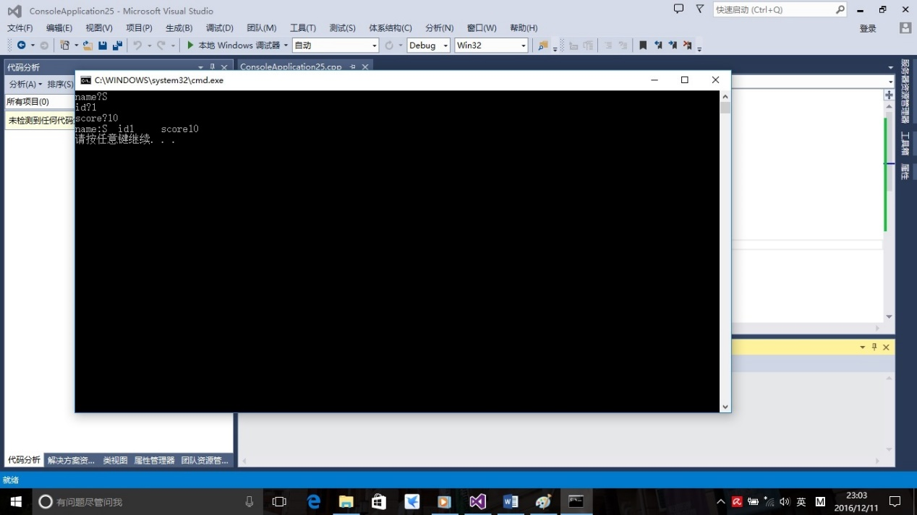

P242 1

#include "stdafx.h"

#include<iostream>

using namespace std;

class book

{

public:char bookname[100];

double price = 130;

int number = 100;

void display()

{

cout << "bookname:"<<bookname << "price:" << price << "number:" << number;

}

void borrow()

{

number--;

cout << "current number:" << number;

}

void restore()

{

number++;

cout << "current number:" << number;

}

};

int main()

{

char bookname[100] = "C";

int a;

book b;

cout << "1 for display, 2 for borrow, 3 for restore";

cin >> a;

switch (a)

{

case 1:b.display(); break;

case 2:b.borrow(); break;

case 3:b.restore(); break;

default:cout << "Please input a right instruction!";

}

}

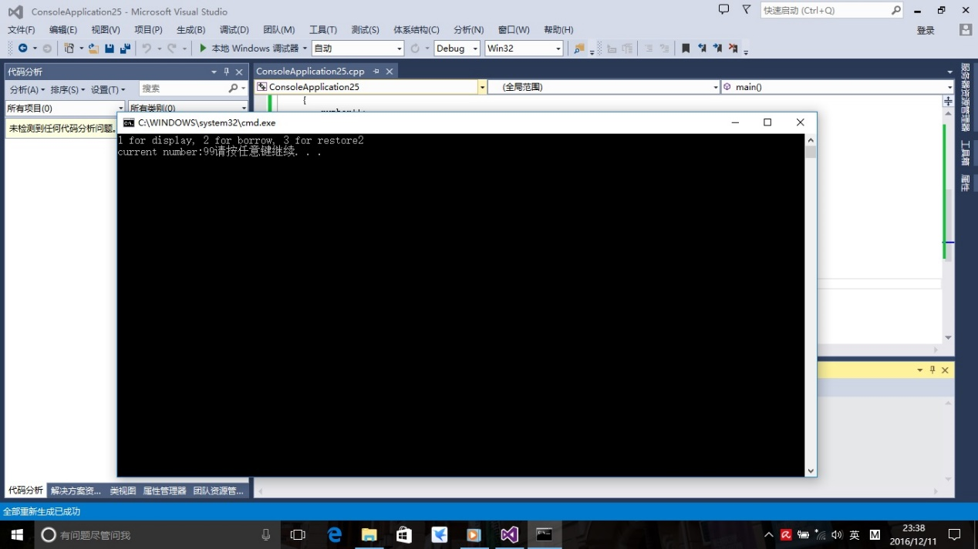

P242 3

不会。。。。。。。。。